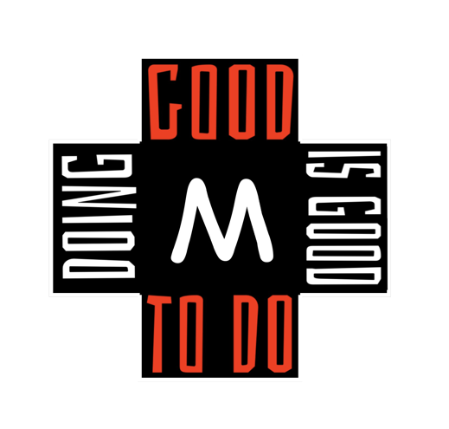
LaValla Weekend
Packing List

Clothing:
Pack comfortable appropriate cloths
  - T-shirts/shorts/jeans enough for 4 days
  - Clothing for outside work
  - You will receive a t-shirt to wear Monday
  - Sneakers/Tennis Shoes must be worn.

Toiletries:
Soap
Shampoo
Toothpaste
Toothbrush
Deodorant

Bedding:
We are very limited in extra so please remember!
Twin Extra Long Bed Sheets
Pillow Case
Towel

Trade – ables:
Items with your school name/logo are fun to trade
  - T-Shirts
  - Sweatshirts

Extra Money:
Marist Young Adults will be selling the “Got Marist?” T-shirts for $20 each. As well as St. Marcellin Champagnat Medals for $5. Also Esopus shirts and apparel will be on sale.

Follow @MaristYouthUSA on Instagram
www.MaristYouth.com

